
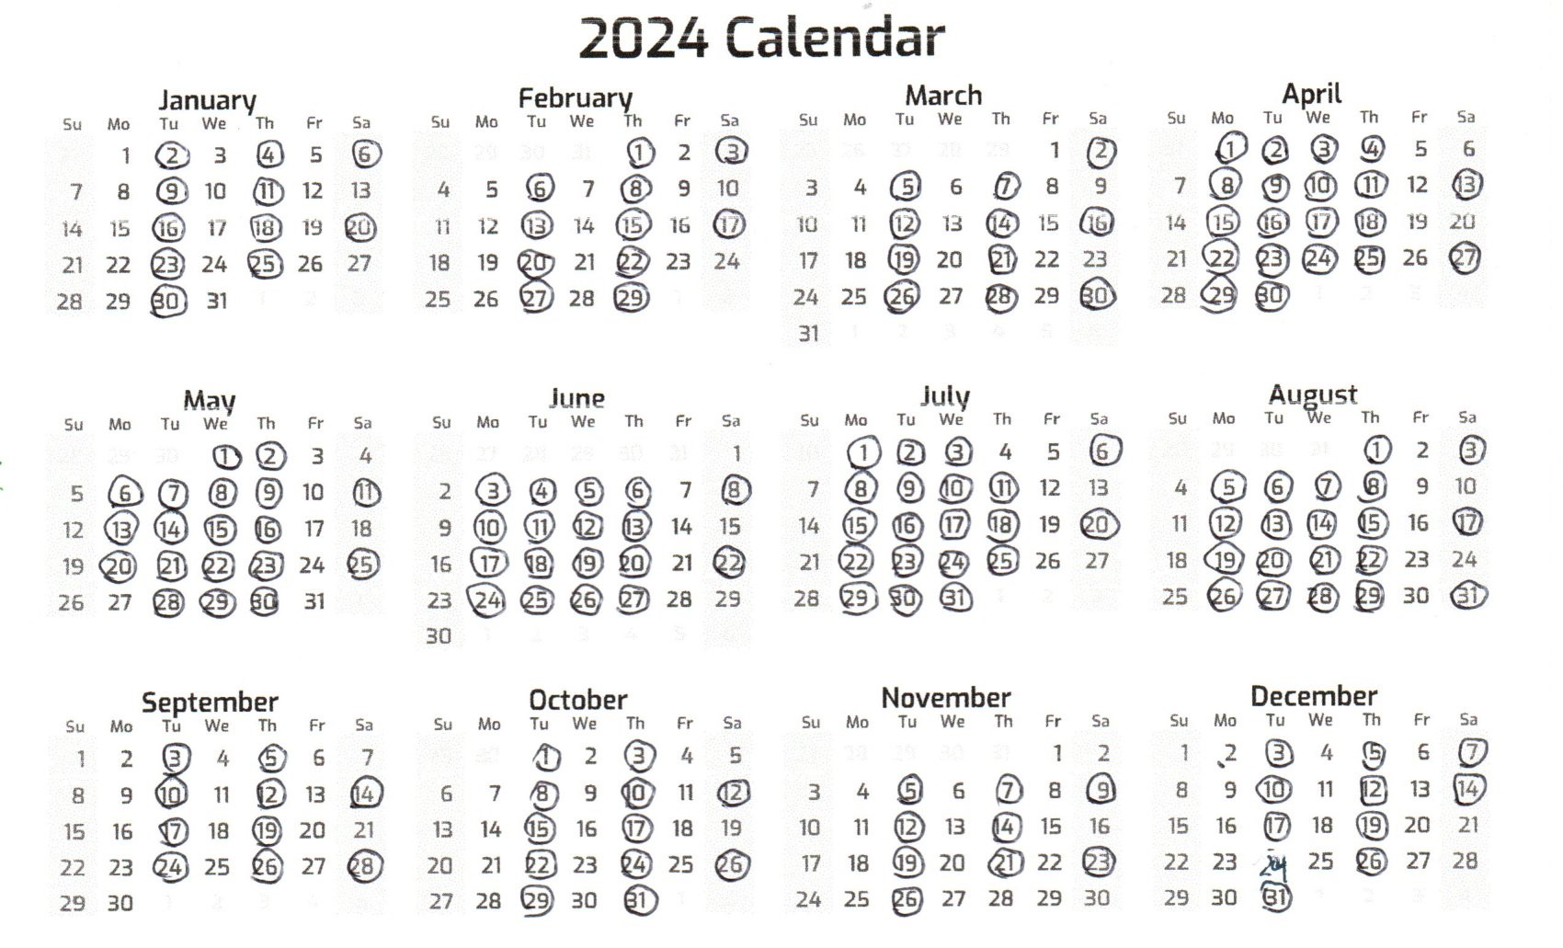
We are open every Tuesday and Thursday 8:00 a.m.-4:00 p.m.. We are also open every other Saturday 8:00 a.m.-12:00 noon as follows: January 6th & 20th, February 3rd & 17th, March 2nd, 16th & 30th, April 13th & 27th, May 11th & 25th, June 8th & 22nd, July 6th & 20th, August 3rd, 17th & 31st, September 14th & 28th, October 12th & 26th, December 7th & 14th.
We will be open Monday and Wednesday evenings 5:00 -7:00 p.m. only in the months of April through August. All hours are subject to change with staffing fluctuations. Our Kid’s Shopping Day in December will take place on December 14th in coordination with the Boy Scout’s visit with Santa.
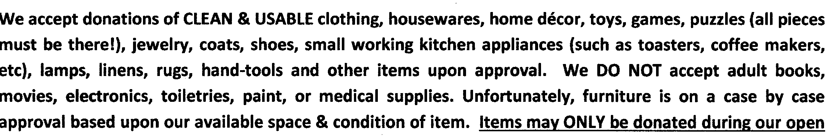hours, in person, & given to a staff member. We will occasionally accept items in our off hours by prior arrangement with a staff member. Items left anonymously on our door step will be thrown away!!
We reserve the right to refuse any item that we deem unacceptable (dirty, torn, out-dated, broken, etc.)!!

